Test Cases & Requirements Test Coverage Report

Group: Team Inspiration Project: Friendstagram

Requirements | No. of Test Cases | Test Cases Passed | Test Cases Failed
Register account | 20 | 20 | 0
Log into account | 2 | 2 | 0
Log out account | 1 | 1 | 0
Find friends | 2 | 2 | 0
View recommended friend profile | 1 | 1 | 0
View personal profile | 1 | 1 | 0
Edit personal profile | 3 | 3 | 0
Register account | 3 | 3 | 0

Blackbox Test Cases

Register Account
Test Scenario ID | 1 | Test Case ID | 1
Test Case Description | Ensure that the user is able to enter valid email and password within confined constraints. | Test Priority | Medium
Prerequisite |  | Post-Requisite | User is brought to the questionnaire page.
Test Execution Steps:
Test Cases | Email’s Input | Password’s Input | Expected output | Test Output
Key in Email & Password
Empty Email | - | - | Email field is empty! | Email field is empty!
Empty Password | - | - | Password field is empty! | Password field is empty!
Invalid Email | hello | - | Invalid email address! | Invalid email address!
Common Password (Need special characters) | - | 123456 | The password is too common. | The password is too common.
Not matching password | - | 1234 | The passwords do not match. | The passwords do not match.
Password is too short (Lower than 8 characters) | - | hello | Password is too short! | Password is too short!
Only Numeric Password | - | 123456 | This password is entirely numeric | This password is entirely numeric
Questionnaire 1 - Select a hall
Test Cases | Input | Expected output | Test Output
User does not select any hall. | - | “Continue to next question” button is light-blue and user not allowed to click on it. | “Continue to next question” button is light-blue and user not allowed to click on it.
User selects a hall. | Hall 1 | “Continue to next question” button turns dark blue and user is allowed to click on it. | “Continue to next question” button turns dark blue and user is allowed to click on it.
Questionnaire 2 - Interests Selection
Test Cases | Input | Expected output | Test Output
User does not select any interest. | - | “Continue to next question” button is light-blue and users are not allowed to click on it. | “Continue to next question” button is light-blue and users are not allowed to click on it.
User select an interest | playing computer games | (1) The background of the selected interest turns grey.  (2) “Continue to next question” button turns dark blue and the user is allowed to click on it. | (1) The background of the selected interest turns grey.  (2) “Continue to next question” button turns dark blue and the user is allowed to click on it.
User selects multiple interests | playing computer games, studying | (1) The background of the selected interest turns grey.  (2) “Continue to next question” button turns dark blue and the user is allowed to click on it. | (1) The background of the selected interest turns grey.  (2) “Continue to next question” button turns dark blue and the user is allowed to click on it.
User unselects interest and the total number of selection > 1 | playing computer games [studying]  Note: []; indicates removal | (1) When unselected, the background of the image should transit from grey to default.  (2) “Continue to next question” button turns dark blue and the user is allowed to click on it. | (1) When unselected, the background of the image should transit from grey to default.  (2) “Continue to next question” button turns dark blue and the user is allowed to click on it.
User unselects interest and the total number of selection < 1 | [studying]  Note: []; indicates removal | 1) When unselected, the background of the image should transit from grey to default.  2) “Continue to next question” button is light-blue and user not allowed to click on it. | 1) When unselected, the background of the image should transit from grey to default.  2) “Continue to next question” button is light-blue and the user is not allowed to click on it.
Questionnaire 3 - Rate Interests
Test Cases | Input | Expected output | Test Output
User drags the button across the  slider bar | User drags | Position of button & value changes accordingly from 1 to 5. | Position of button & value changes accordingly from 1 to 5.
User drags the button to the most right end of the slider bar. | 5 | Position of the button is at the most right end of the slider bar and the value reflects 5. | Position of the button is at the most right end of the slider bar and the value reflects 5.
User drags the button to the most left end of the slider bar. | 1 | Position of the button is at the end of the slider bar and the value reflects 1. | Position of the button is at the end of the slider bar and the value reflects 1.
Questionnaire 4 - Input Bio
Test Cases | Input | Expected output | Test Output
User does not have any input. | - | “Continue to next question” button is light-blue and the user is not allowed to click on it. | “Continue to next question” button is light-blue and the user is not allowed to click on it.
User inputs less than 10 characters. (Inclusive of white spaces) | hello | “Continue to next question” button is light-blue and the user is not allowed to click on it. | “Continue to next question” button is light-blue and the user is not allowed to click on it.
User inputs more than 10 characters. (Inclusive white spaces) | Hello I am great | “Continue to next question” button turns dark blue and the user is allowed to click on it. | “Continue to next question” button turns dark blue and the user is allowed to click on it.

Log into account
Test Scenario ID |  | 2 |  |  | Test Case ID |  | 2
Test Case Description |  | Authenticate the user into the system |  |  | Test Priority |  | High
Prerequisite |  | - User is not yet authenticated into the system  - User is in home page |  |  | Post-Requisite |  | User successfully logs into account
Test Execution Steps:
S.No | Action |  | Inputs | Expected Output |  | Actual Output | Test Result | Test Comments
1 | User enters the required fields |  | 1. Users enter their registered email  2. Users enter their registered password | The input entered in the fields are displayed for the user to see, except for the password which is shown as dots. |  | The input entered in the fields are displayed for the user to see, except for the password which is shown as dots. | Pass | User is able to view the inputs entered into email field
2 | User press the “Sign in” button |  | NIL | User is brought to the Home Page and is able to access the “Find Friend” button. “My Profile” & “Log Out” buttons are also accessible via the navbar. |  | User is brought to the Home Page and is able to access the “Find Friend” button. “My Profile” & “Log Out” buttons are also accessible via the navbar. | Pass | User is brought to the Main Menu and is able to access the “Find Friend” button. “My Profile” & “Log Out” buttons are also accessible via the navbar.

Log out account
Test Scenario ID |  | 3 |  |  | Test Case ID | 3
Test Case Description |  | User logs out of their personal account |  |  | Priority | Medium
Prerequisite |  | User must be logged in |  |  | Post-requisite | - User will be logged out of their account  - System will return to the state for an unauthenticated user
Test Execution Step:
Test Case |  | Actions | Expected Output |  |  | Test Output
Log out |  | User press the “Logout” button | User is brought to the Main Menu and is not able to access the browse and profile page now |  |  | User is brought to the Main Menu and is not able to access the browse and profile page now

Find Friends (Match Page)

Test Scenario ID |  | 4 |  |  | Test Case ID |  | 4
Test Case Description |  | User requests for recommendation on new potential friends |  |  | Test Priority |  | High
Prerequisite |  | Users is logged in and is in homepage |  |  | Post-Requisite |  | User sees a ‘friends matched’ page, showing a list of cards. Each card represented a potential new friend.

Test Case |  | Actions | Expected Output |  | Test Output
User waits for the friends matching  result. |  |  | UI display loader animation to indicate that the client is awaiting for server’s data. |  | UI displays loader animation to indicate that the client is awaiting for server’s data.
Successful  Friends matching result. |  |  | User is shown a catalog of matched friends, each represented as a card. |  | User is shown a catalog of matched friends, each represented as a card.

View recommended friend profile
Test Scenario ID |  | 5 |  |  | Test Case ID |  | 5
Test Case Description |  | User chooses to see a recommended friend profile |  |  | Test Priority |  | High
Prerequisite |  | 1. User is on the ‘friends matched’ page.  2. User is logged in. |  |  | Post-Requisite |  | User sees the profile of the chosen recommended friend which shows the name, lists of interests and email

Test Case |  | Actions | Expected Output |  | Test Output
User is able to view a friend's profile by clicking on the `View Profile` button. |  | User clicks on the `View Profile` button. | User will be brought to the selected profile page. Selected profile page will contain the following categories, `email`, `bio`, `hall` and `interests`. |  | User brought to the selected profile page. Selected profile page will contain the following categories, `email`, `bio`, `hall` and `interests`.

View Personal Profile
Test Scenario ID |  | 6 |  |  | Test Case ID |  | 6
Test Case Description |  | User wants to view his/her personal profile |  |  | Test Priority |  | High
Prerequisite |  | User is logged in |  |  | Post-Requisite |  | User sees his/her own profile and history of matched friends

Test Case |  | Actions | Expected Output |  | Test Output
User will be able to view the personal profile by clicking on the `My Profile` button. |  | User clicks on the `My Profile` button. | User will be brought to the personal profile page. The personal profile will contain the following categories, `personal information`, `selected interests` and `matched history`. |  | User was brought to the personal profile page. The personal profile will contain the following categories, `personal information`, `selected interests` and `matched history`.

Edit personal profile
Test Scenario ID |  | 7 |  |  | Test Case ID |  | 7
Test Case Description |  | User wants to edit his/her personal profile |  |  | Test Priority |  | Medium
Prerequisite |  | 1. User is logged in  2. User is in the “Profile” Page. |  |  | Post-Requisite |  | User sees his/her own updated profile with personal information like email, interest, hall accommodation details and history of matched friends

Test Case | Actions | Expected Output | Test Output
User hovers the cursor over the `Edit` button in the `My Profile` page. | User hovers the cursor over the `Edit` Button. | Button changes from plain to dark blue. | Button changes from plain to dark blue.
User clicks on the button `Edit Button`. | User clicks on the `Edit Button` | User is brought to Questionnaire 1 Page - Selection of Hall. | User is brought to Questionnaire 1 Page - Selection of Hall.
User is able to view the successfully edited personal profile. | - User inputs hall 7 (previously hall 7).  - User selects the same interest of `dancing` (previously dancing).  - User choose the same rating of dancing `4` (previously `4`).  - User inputs a different bio `I am fun person` (previously `I am studious`) | User is brought back to the `My Profile` page with the successfully edited changes of bio `I am fun person` instead of the `I am studious` person. | User is brought back to the `My Profile` page with the successfully edited changes of bio `I am fun person` instead of the `I am studious` person.

Whitebox Testing

Test Coverage for Backend
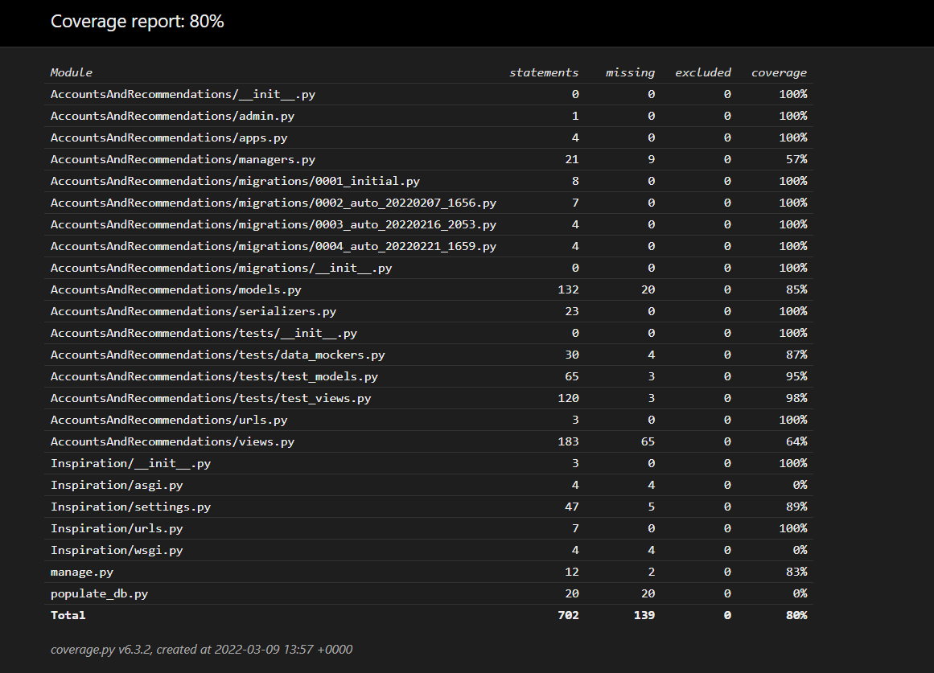

Performance Testing
We performed load/stress testing to measure the reliability of the system under load. Since we host on free tranches of our service providers Netlify and PythonAnywhere, we limit projected load to 50 users. Under our reliability metrics, we must keep our uptime above five 9’s of availability. We demonstrate that we can fulfill this requirement, with no packet loss under heavy load, with the server remaining up. Responses are provided at 1.1s on average.

